**PROBLEM NUMBER 3: Power Harvesting**

**Develop an economical and sustainable solution of power harvesting on construction sites at Weigh Bridges and under the loading point of production plants.**

**INTRODUCTION**:

Energy is the basic need for the development of the modern world. For meeting up the regular demand of energy we need to design a system that will produce electricity without destroying the nature. This synopsis attempts to show how we can utilize and optimize kinetic energy. Researches show that the world has already had its enough shares of its energy resources. Fossil fuels pollute the environment. Nuclear energy requires careful handling of both raw as well as waste material. The focus now is shifting more and more towards the renewable sources of energy, which are essentially, non-polluting. This synopsis attempts to show how energy can be produced, stored and used using the road transport pressure or any kind of pressure. Although energy is used in the project life cycle at different levels, it is during building operation that the bulk of energy is consumed . However, it is important to account for energy usage at all levels of the building life cycle. Construction operations consume huge amounts of energy in various forms but have never been sufficiently accounted for. A significant portion of energy utilization on construction site is associated with the mechanical plant used for transportation, levelling, earthworks, lifting, compacting and mixing, including the embodied energy in materials extraction.

**TECHNICAL, ENGINEERING AND SOCIAL ASPECTS**

Our solution is based on the following technologies –

**1.Piezoectric weighbridge**

**2.smart speed breakers.**

**3.piezoelectric bed of loading point.**

**4.e-vehicles in production plants.**

**5.Hi-tech shoes for workers**

**6.Piezoelectric footpath.**

**Piezoelectric weighbridge**-When a large or bulky materials such as trucks enters any construction sites it is necessary to weigh the vehicle. For this weighbridges are used there. We can use this weighbridge for storing energy which can be later used for variety of purposes such as street lights in the construction sites. We propose that piezo electric sensors can be embedded under the weighbridge. Due to the loading at the weighbridge stress is generated and the piezoelectric sensor produce electricity which is stored in a rechargeable battery.

**Smart Speed-Breakers**-

**For energy generation-**Speed breaker is very much essential everywhere and can be very useful in any construction site Speed breaker working on rack and pinion mechanism can be used to generate electricity and store it. The weight of the passing vehicles on the speed vehicle will engage rachet to pinion which can drive the shaft of the motor to generate electricity and store it .This smart speed break will not only prevent any accident but will also generate electricity to be used for other purposes.

**For security-**This speed breaker will also be used for security purposes of the construction sites.For example if a lorry enters the construction site at night and the security personal is asleap then in the morning also he will be unaware of that fact that an unauthorized vehicle went inside and will definitely not verify the cctv footage of last night.But a count of the number of vehicle entered in the plant will definitely serve the issue of security here.

**Piezoelectric bed of production site**-At the loading points of any production plant there are lots of small vehicles is used for loading and unloading of various components .Instead of using fuel for running these vehicles we can use indigenously created electricity from the bed of the warehouse itself. We can embed piezoelectric sensors in the floor of the warehouse and use the electricity produced to power the e-vehicle.

**Hi-tech shoes**-

**For energy generation**-As we know that piezo sensors can generate electricity when stress is applied on it. We can apply this property to produce small amount of DC electricity which can be used by the worker for charging his/her mobile phone. A small compartment will be provided in the shoes of the walkers where piezo sensors will be embedded. A small USB port will be made to give the required output for charging his/her cell-phone.

**For safety-**If a worker is working in certain high risk areas such as mines, if the battery of his head torch goes off then definitely he would be trapped there but we can put a small led light in his shoes which is powered by the enegy generated due to mechanical stress.

**Piezoelectric Footpath-** Piezoelectic sensors can be embedded in the footpaths which can be later used to power the street lights at night.This technology is not new and is already implemented in California and Israel and should must be implemented in India as well.

**WORKING OF THE SOLUTION-**

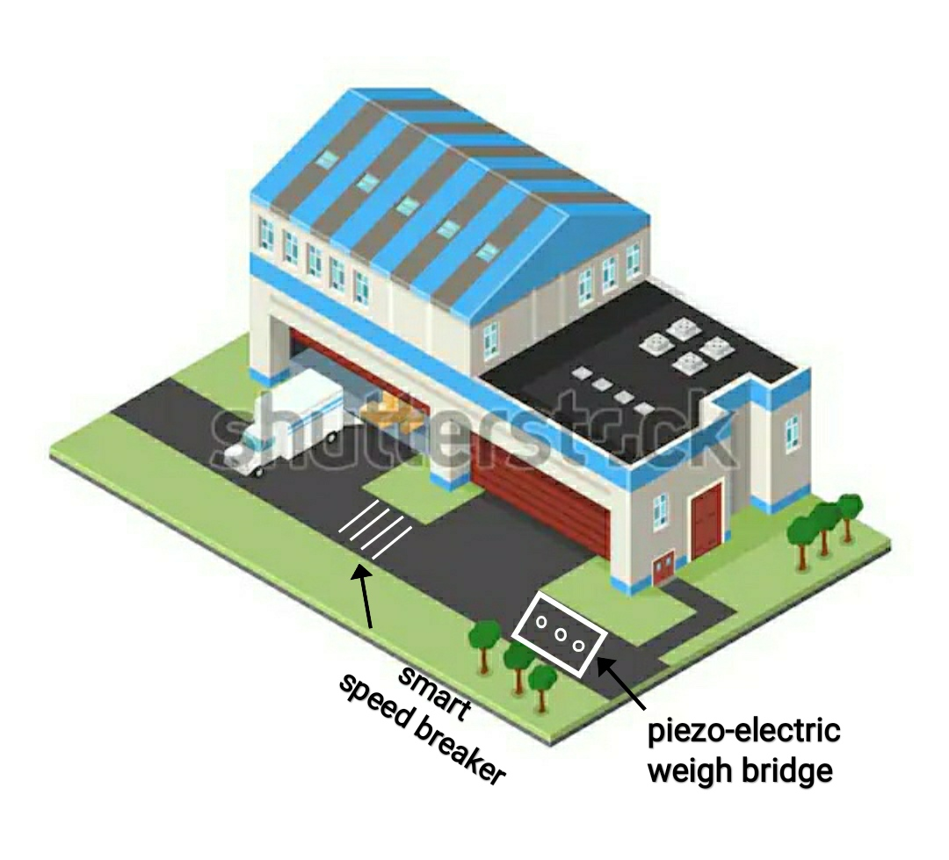

**CONSTRUCTION SITE**

**For the smart speed breaker mechanism click** [**HERE**](https://drive.google.com/file/d/1ydEcO9jH-sKUK0aPIgqZwL3rURT5iLzC/view?usp=drivesdk)

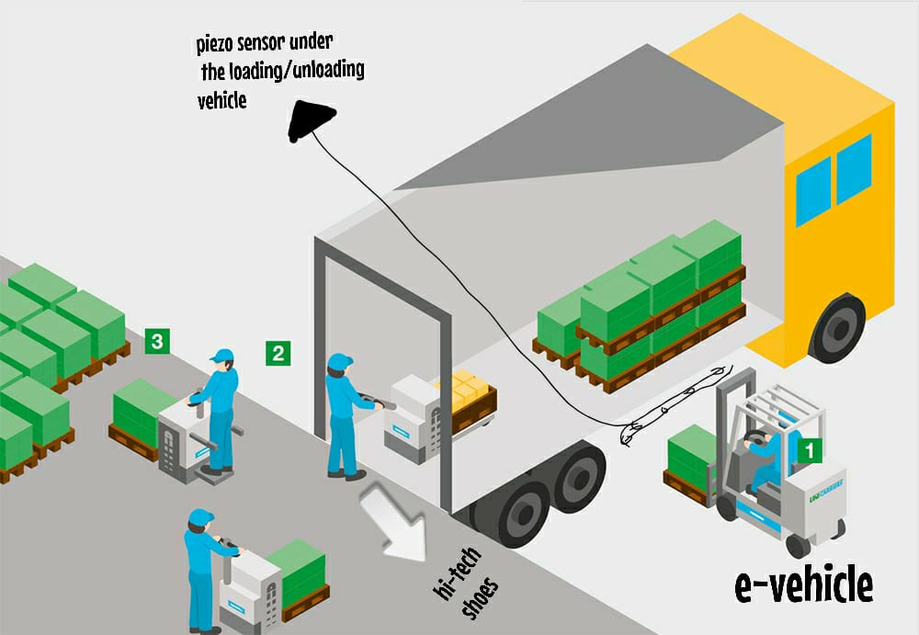 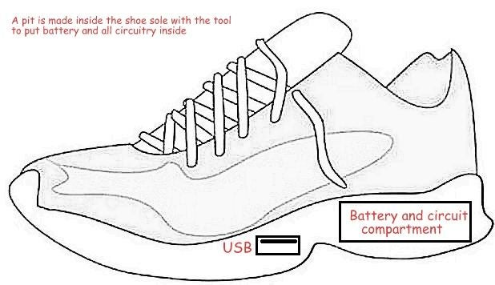

**LOADING POINT OF PRODUCTION UNIT HI-TECH SHOES**

**ADVANTAGES:**

• Generation of power without polluting the environment.

• Simple construction, mature technology and easy maintenance.

• No fuel transportation required.

• No consumption of any fossil fuel which is non-renewable source of energy.

• No external source is needed for power generation.

**CONCLUSION**:

In coming days, it will prove a great boon to the world, since it will save a lot of electricity of power plants that gets wasted . As the conventional source are depleting very fast, then it’s time to think of alternatives. We got to save the power gained from the conventional sources for efficient use. So this idea not only provides alternative but also adds to the economy of the country. Now the time has come to put forward this type of innovative ideas, and also researches should be done to upgrade its implication. In future, if the flywheel speed control device and voltage protection devices are added with large generation process, it would be a model all over the world .